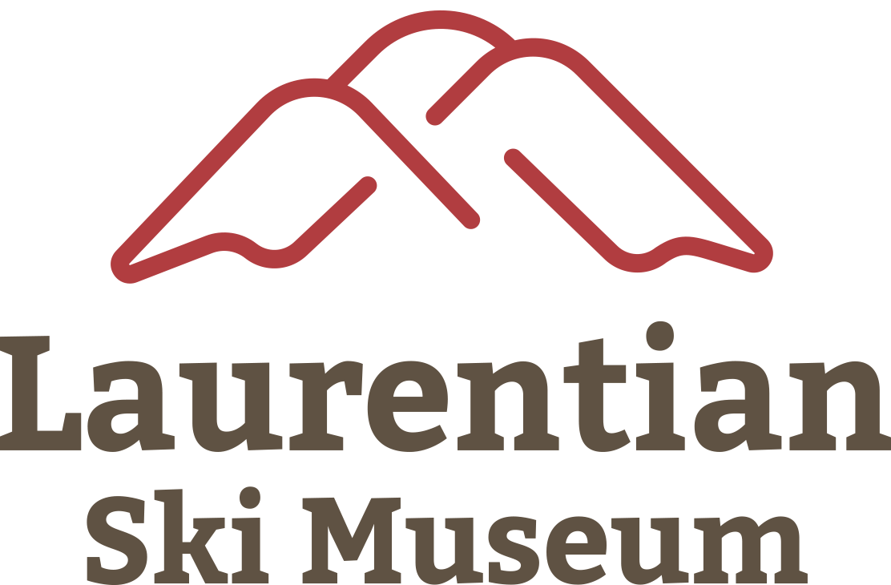

**Laurentian Ski Museum**

6, av. de la Gare Saint-Sauveur, Qc

J0R 1R0

Phone : 450-744-1723

Email: [info@museeduski.com](mailto:info@museeduski.com)

Web site : [www.museeduski.com](http://www.museeduski.com)

**Donation Agreement - Laurentian Ski Museum**

Between the donor named here after (Name and first name of the donor or donors)

Name:…………………………………………………………………… Email: ………………………………………….

Address: ……………………………………………………………………………………...

Phone number:……………........................

On one side, and the Laurentian Ski Museum on the other

It is understood that:

Article 1 - The donor donates in a complete and definitive way to the Laurentian Ski Museum the following objects, photos, books, films or documents, of which he is the owner and that free of rights:

…………………………………………………………………………………………………………………………………………………………………………………………………………………………………………………………………………………………………………………………………………………………………………………………………………………………………………………………………………………………………………………………………………………………………………

Article 2 - The donor certifies, in good faith, that the history of these objects, photos, books, films or documents is as follows:

…………………………………………………………………………………………………………………………………………………………………………………………………………………………………………………………………………………………………………………………………………………………………………………………………………………………………………………………………………………………………………………………………………………………………………

Article 3 - The Laurentian Ski Museum accepts this donation.

Article 4 - The donor agrees that refurbishment operations can be carried out on these objects, film photos or documents for presentation to the public in the context of events or exhibitions.

Written in …………………………………. **In two copies**, on ………………………………..20……

The donor Representing the Laurentian Ski Museum

……………………………………………………… ……………………………………………………………

The action of the donor may be transmitted in the communications or information media /social media made by the Museum.

The name of the donor may be associated with the object